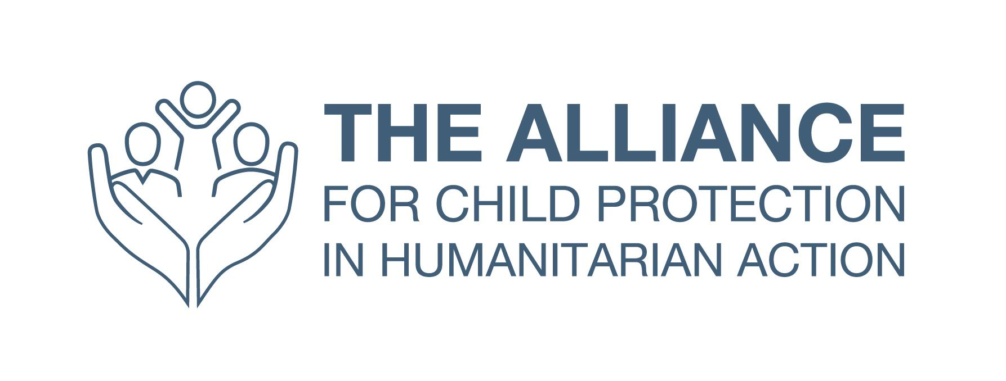

Terms of Reference: Convening Focal Point

Location: Home-based

Contract type: Consultancy until end June/early July 2023 (with possibility of extension)

Reporting to: Co-Coordinator of the Alliance for Child Protection in Humanitarian Action

Line manager for: None

The Alliance for Child Protection in Humanitarian Action (the Alliance) is a global network of operational agencies, academic institutions, policymakers, donors and practitioners that facilitates inter-agency technical collaboration on child protection in all humanitarian contexts. The United Nations Children’s Fund (UNICEF) leads the Alliance with a rotating NGO, currently World Vision International. The Alliance sets standards and produces technical guidance for use by the various stakeholders, particularly field practitioners. Its mission is to support humanitarian actors to achieve high-quality and effective child protection interventions in humanitarian contexts, in both refugee and non-refugee settings.

The Alliance Convening Focal Point is a central resource for the whole Secretariat and Working Groups and Task Forces, providing administrative and logistical support for events and meetings, and ensuring they are well-organised, engaging and of quality.

KEY RESPONSIBILITIES:

1. Support the organisation of the 2023 Annual Meeting for Child Protection in Humanitarian Action as required.
- ​Liaise and coordinate with all relevant actors, including the secretariat, working group and task force (and initiative) leads, Annual Meeting Task Team, etc.
- Work closely with the event company for design, planning and delivery of the event.
- Develop, manage and update key tools to support organisation and coordination of the event, and communication of these to relevant actors.
- Support facilitators and speakers (and step in as an alternate facilitator if needed)
- Manage communication with participants, speakers and facilitators by monitoring the Annual Meeting email address.
- Support the knowledge management focal point with communication and reporting on the event.
- Document lessons learned for use in future events.
- Support the abstract review committee in the review and decision making processes.
- Support the piloting and documentation of “participation hubs” as a potential model for expanding opportunities for participation of local and national organisations.

2. Support the organisation of Alliance meetings, webinars and online events
- Support the secretariat as well as Working Group, Task Force and Initiative leads, on organising online and face to face events as necessary.

PERSON SPECIFICATION:

Education, Qualifications, Knowledge and Experience:

Essential:

- Bachelor's degree in relevant fields
- Direct experience of organising large online and/or face to face events
- Strong administration experience including supporting budgeting and expense processing
- Experience of effective communication at all levels across an organisation
- Experience of working in a multicultural setting, ideally in more than one language (and ideally including Arabic, French, or Spanish), demonstrating understanding of working internationally and;
- High level of fluency in written and spoken English.

Desirable:

- Experience of working within a network organisation / Alliance
- Experience of working with Google Apps
- Experience of working with Zoom, both Zoom Meetings and Zoom Webinars
- Experience of project management, including experience of setting up and using simple project management tools
- Familiarity with the child protection field
- Familiarity with the humanitarian sector

Skills and Personal Attributes:

- Flexible and adaptable; willing to contribute to other streams of work and across teams
- Highly skilled communicator, in different formats, and capable of working across languages and cultures (making efficient and effective use of translation support)
- Flexibility to work outside normal working hours and across time zones
- Highly organised and self-motivated, able to manage and deliver on multiple concurrent tasks
- Competent IT proficiency across a range of packages, able to learn quickly and troubleshoot problems independently
- Ability to use initiative and work without close supervision, working both as part of a team and as an individual within a remote-working organisation

HOW TO APPLY:

Please send a brief cover letter outlining how you meet the criteria, skills and attributes, your CV, daily rate and availability by 20 February 2023 to info@alliancecpha.org.

